

**From,**

**Tata Steel BSL Limited,**

At- Khopoli,

 Via / Taluka- Khalapur,

 Dist- Raigad

410203

Maharashtra

**To:**

**General Manager**

**APGVB**

**Branch : Challagarige**

**M: Chityal**

**D: Jayashankar Bhupalpally**

**S: Telangana**

**506356**

Subject: To Claim Fixed Deposit bonds accrued in APGVB Challagarige

Respected Sir,

Myself Bharath kumar aitha Residence of Challagarige S/o Srinivas aitha requesting you to claim my fixed deposits bond mentioned below and transfer money to my father’s savings account in my absence due to no leave sanctioned by my management cadre.So, I cannot come to bank.Kindly transfer total money including interest to my father’s account.Hope you understand the issue and kindly do needful**.**

**F.D numbers.**

**Receipt no-**1)964619,A/C- 73124449873

2)804360,A/C-73112160818

3)758659,A/C-73147401209

**Transfer to A/C : 73081889626—AITHA SRINIVAS**

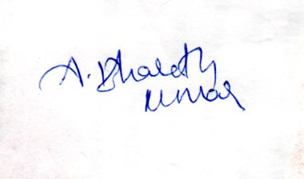

T